Content

# Chapter 1. Theory

## EMI in details

### EMC compliance

### EMI Definition

### EMI Classifications.

## EMI Filter Design

### Design Flow

### Schematic Design

## RF Emissions Analysis

### Conducted Emissions

### Radiated Emissions

# Chapter 2. Filter mode

## Conducted Emission Analysis

### Common Mode Interference

### Differential Mode Interference

## Material Selection for Hardware Design

### Filter pattern

### Choke selection

### Lumped elements

### PCB design

## Signal Source Selection

### Single tone signal

### Multi tone signal

# Chapter 3. Filter Behavior Prediction

## Linear Simulation

### S-parameter measurement

## Non-Linear Simulation

### Voltage and current measurement

### Power measurement

### Stability measurent

### Attenuation measurement

# Chapter 4. Measurement and Comparison of Simulations

# Chapter 5. Result Estimation and Discussion

## Case Study 1: Filter for 50Hz

## Case Study 2: Experimental Examples

### USB cables

### Ethernet cables

# CHAPTER 1. THEORY

## EMI details

### EMC compliance

In an designed system, electronic or electrical devices emit a large amount of electromagnetic interference known as radiated and conducted emissions and electromagnetic immunity know as conducted and radiated immunity. These emission and immunity inherent the overall performances of the system and may cause unwanted effects such as physical damage of the equipment. Electromagnetic compatibility (EMC) is the measurement ability of equipment in electromagnetic environment without introducing intolerable electromagnetic disturbance to function satisfactorily. EMC limits the unintentional generation, propagation and reception of electromagnetic energy.

EMC pursues two main classes of issue. EMC may be achieved by addressing any or all of these issues.

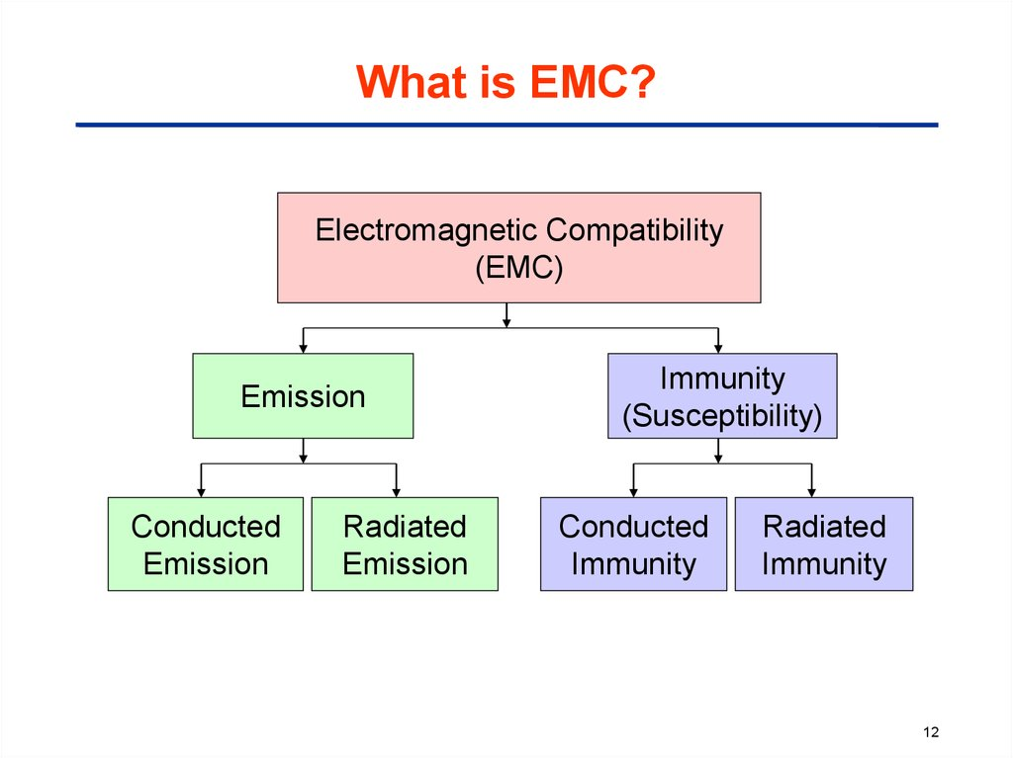

https://en.ppt-online.org/152151

**Emission** is the production and discharging of electromagnetic energy by some source whether deliberate or accidental way, that release into the environment. EMC takes these unwanted emissions into consideration and countermeasures which mostly reduce unwanted emissions.

**Susceptibility** isreferred to the victim electrical equipment that become malfunctioned or break down in the presence of unwanted emissions, also known as Radio frequency interference (RFI). Therefore, **Immunity** is the ability of equipment to function correctly in the presence of RFI. "Hardening" equipment is known equally as susceptibility or immunity.

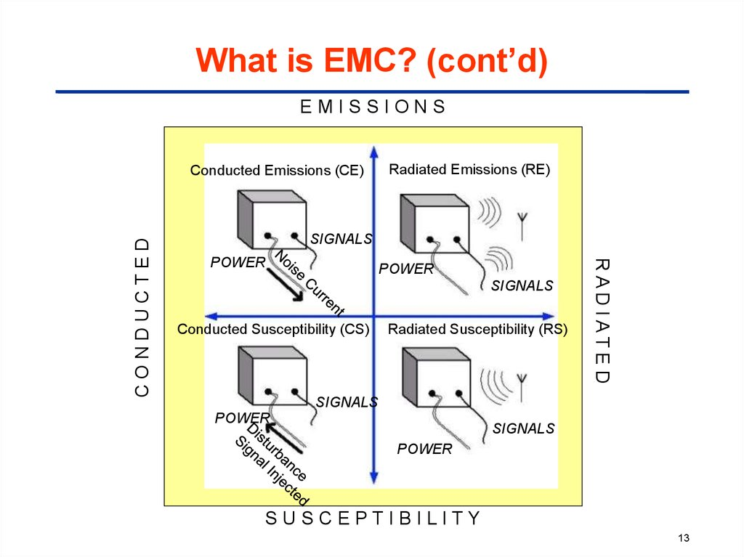

A third issue which is a very common content of EMC is **coupling. Coupling** is the mechanism by which emitted interference reaches the victim.

(https://en.wikipedia.org/wiki/Electromagnetic_compatibility)

### EMI Definition

Electromagnetic Interference is referred as an electromagnetic disturbance which may degrade the performance of a device, equipment, system or subsystem and cause malfunction of the equipment due to the generation of either electromagnetic induction or externally emitted electromagnetic radiation.

Generally when an electric field comes in contact with a magnetic field, electromagnetic (EM) waves are generated. EM waves travel at a speed of light 3.0 × 108 ms-1 in a vacuum. EM waves can travel over anything, such as air, water, a solid material, or a vacuum. It occurs when an electronic device is unshielded to an electromagnetic field and any device that has electronic circuitry and also connected with power supply, can be responsive to EMI.

EMI is the combination of two or more waves which can results greater, lesser, or equal measured wave than the original one. Hence, the resulting wave may potentially different to the original waves and may also potentially unsuitable for its purpose.

### Electromagnetic Interference Classification

1. EMI can be generated from different sources. The way of classifying the EMI types is done by the way it was generated:

**Human made EMI:** This type of EMI generally generated from the electronics circuits or electrical devices. Example as power lines, auto ignition, fluorescent lights, and so on.

**Naturally induced EMI:** This type of EMI can be generated from many sources like extraterrestrial sources including radiation from the sun and galactic sources including radio stars, galaxies, and other cosmic sources, atmospheric charge/ discharge like lightning.

1. Second method of classifying the EMI types is by its duration:

**Continuous interference:** When a circuit is connected to a source and emits a continuous signal then this type of EMI generally arises from that source. However background continuous noise may be created in a number of ways either it is human made or naturally induced.

**Impulse interference:** Including lightning, ESD, and switching systems all those which contribute to impulse noise, is a form of EMI. This type of EMI may be generated by human made or naturally.

1. EMI can also be classified according by their bandwidth.

**Narrowband:** This EMI is likely to be a single carrier source. The signal that is caused by intermodulation and other forms of distortion in a transmitter, also a form of narrowband EMI which may appear at different points in the spectrum and may cause interference to another user of the radio spectrum.

**Broadband:** Broadband EMI can arise from a great variety of sources. Man-made broadband interference can be generated from sources spark is continuously generated. Naturally occurring broadband noise can be generated from the Sun. Actually when the Sun appears behind the satellite and noise can mask the wanted satellite signal.

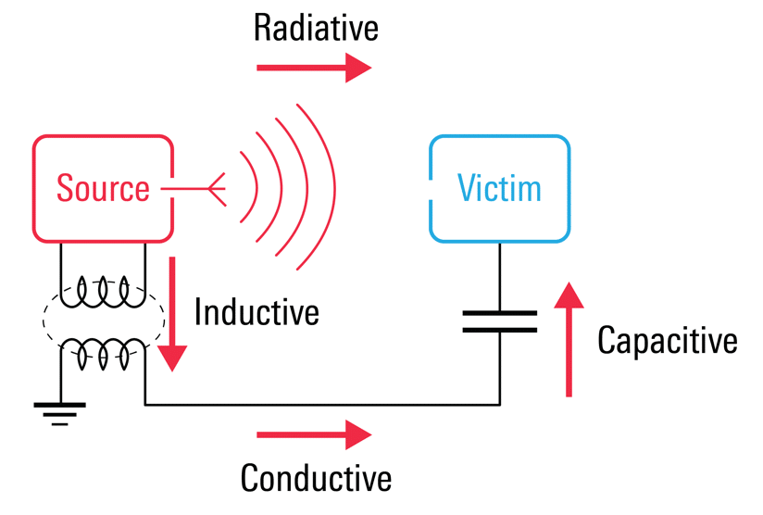

https://interferencetechnology.com/cost-effectively-ensure-electromagnetic-compatibility-in-the-age-of-iot/maxwellfig3/

## EMI Filter Design

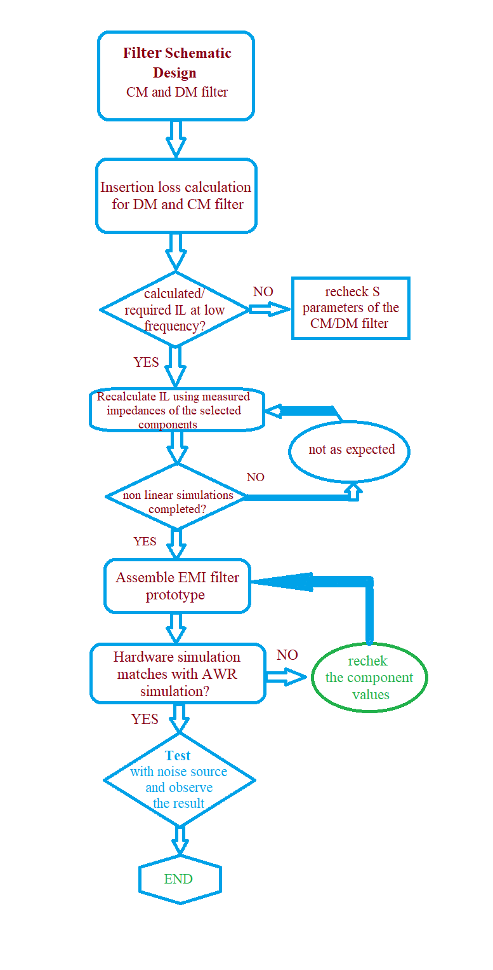

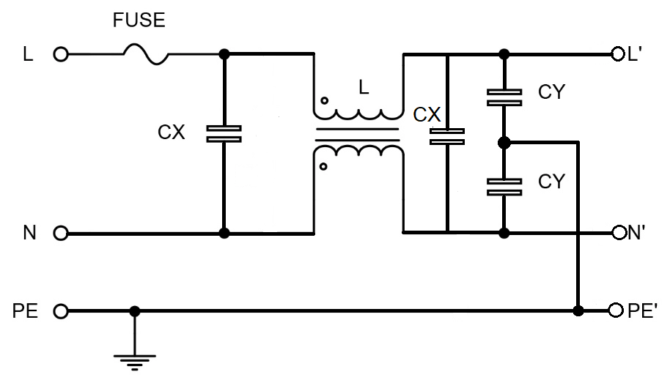

**WHAT IS ELECTROMAGNETIC COMPATIBILITY (EMC) TESTING?**

Electromagnetic compatibility (EMC) testing measures the ability of equipment or systems to function satisfactorily in their electromagnetic environment without introducing intolerable electromagnetic disturbance to anything in that environment.

**WHY IS EMC TESTING IMPORTANT?**

EMC certifications are a mandatory requirement in most markets, including Europe, the US, China, Korea, Australia and New Zealand. EMC testing is necessary to help you meet regulatory requirements, improve product performance and reduce the risk of costly non-compliance. A third-party EMC test lab can conduct conformity assessments and also help to strengthen your competitive position in the market.

**TÜV SÜD OFFERS A ONE-STOP SERVICE FOR EMC TESTING AND CERTIFICATION**

TÜV SÜD’s experts offer comprehensive testing and certification based on their complete knowledge of EMC legislation, guidelines, and standards. Our testing can cover all types of products, from small appliances to large defence industry machines.

We assist you to resolve any EMC regulatory issues, from design concept to final production. We provide a one-stop service that covers all your testing and certification needs. Our experts provide project management to ensure that your EMC tests run smoothly.

You can choose to have tests performed at our labs, on your premises or anywhere your product is installed.

**TÜV SÜD’S EMC TESTING PROCEDURE**

Our worldwide labs are capable of conducting a comprehensive range of EMC tests and providing you with EMC certifications. Depending on your product, this might include:

* Antenna immunity to RF voltage
* Antenna input immunity
* Antenna screening effectiveness
* Conducted disturbances immunity
* Conducted emissions (continuous and discontinuous interference)
* Electrostatic discharge (ESD) immunity
* Electrical disturbances from conduction and coupling immunity for vehicles
* Electrical fast transient / burst immunity
* Harmonic current emission
* Harmonics and interharmonics immunity
* Immunity from radiated fields
* Immunity to induced voltages
* On-site EMC testing
* Power frequency magnetic field / oscillatory waves immunity
* Power interference
* Power supply conditioning
* Radiated emissions
* Radiated field immunity
* Voltage fluctuation / flicker
* Voltage surge immunity
* Voltage dips / interruptions immunity
* Magnetic filed measurement (EMF)
* Electric field measurement (EMF)
* Electromagnetic field measurement (EMF)
* Induced current density due to the electric field (EMF for lightning equipment)

(https://www.tuvsud.com/en-in/services/testing/electromagnetic-compatibility-testing)

# A guide to Electromagnetic Compatibility (EMC) Testing Methods

Electromagnetic Compatibility (EMC) is the ability of an electronic device to exist in an electromagnetic environment without causing interference to or being interfered with by other electronic devices within that environment. [EMC testing](https://www.emcbayswater.com.au/emc-testing-services/) is typically broken down into two categories:

* **Emissions** – Electromagnetic disturbances emanating from an electronic device that may cause interference/malfunction to another electronic device in the same environment. Also known as Electromagnetic Interference (EMI).
* **Immunity/Susceptibility** – Immunity is the ability of an electronic device to function normally in an electromagnetic environment without experiencing interference/malfunction due to the emissions emanating from another electronic device. Susceptibility is basically the opposite of immunity, in that the less a device is immune to electromagnetic interference, the more susceptible it is. Typically immunity testing is not required for consumer/commercial type products intended for sale/distribution in Australia, New Zealand, North America and Canada.

## **Electromagnetic Compatibility Emissions**

EMC Emissions are further sub-divided into two categories:

* **Radiated Emissions**
* **Conducted Emissions**

An electromagnetic field consists of the following components:

* **Electric Field (E-Field)** – Usually measured in volts per meter (V/M)
* **Magnetic Field (H-field)** – Usually measured in amps per meter (A/m)

These two components of an electromagnetic field are in themselves two separate fields but not totally separate phenomena. E-Fields and H-Fields move at right angles to each other.

**Radiated Emissions (E-Field)**: Radiated emissions are electromagnetic interference (EMI) or disturbances that originate from frequencies generated internally by an electronic or electrical device. Radiated emissions can present challenging compliance issues, for some general guidance please check out our article [EMC Radiated emissions common issues and solutions](https://www.emcbayswater.com.au/blog/emc-testing/emc-radiated-emissions-common-issues-solutions/). Radiated emissions are propagated through the air directly from the device’s chassis or from interconnected cables such as signal ports, wired ports such as telecommunication ports or power conductors. A great example is HDMI ports and the associated EMI that can radiate from these cables, we used it as a case study, the article can be found here; [EMC compliance for HDMI Radiated Emissions testing (EMI)](https://www.emcbayswater.com.au/blog/emc-compliance-hdmi-radiated-emissions-testing-emi/). During EMC testing, radiated emissions measurements are made using a spectrum analyzer and or an EMI receiver and a suitable measuring antenna.

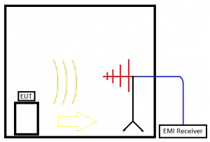

**Radiated Emissions (H-field)**: The magnetic component of the electromagnetic wave is using a spectrum analyzer and or an EMI receiver and a suitable measuring antenna. Typical magnetic field antennas include loop antennas and also include specific antennas as per CISPR 15 such as the Van Veen Loop. The Van Veen Loop antenna is essentially three-loop antennae constructed together that measures the magnetic field emissions of a product in three-axis (X, Y and Z).

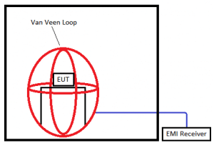

**Conducted Emissions (Both continuous and Discontinuous)**: Conducted emissions are electromagnetic interference (EMI) or disturbances that originate from frequencies generated internally by an electronic or electrical device. These emissions are then propagated along with interconnected cables such as wired ports such as telecommunication ports or power conductors. These emissions can be either continuous (continuously emits at a given frequency) or discontinuous in nature (non-constant, occurring sporadically). During EMC testing, conducted emissions measurements are made on an EMI receiver via an ISN (impedance stabilization network) located within the test chamber. For further information about conducted emissions compliance issues and EMC fixes check out our article; [Conducted EMI Emissions – Typical Problems and Common Solutions](https://www.emcbayswater.com.au/blog/conducted-emi-emissions-typical-problems-common-solutions/).

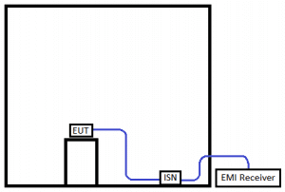

## **Electromagnetic Compatibility Immunity**

EMC immunity testing can be thought of as either continuous or transient in nature. Continuous testing is applied to a product to simulate RF proximity that may occur in the real world. Transient phenomena are typically short events that involve bursts of energy.

EMC immunity testing requirements are often split based on how electromagnetic interference might couple onto a device:

* **Immunity, enclosure port**
* **Immunity, signal ports and telecommunications ports**
* **Immunity, input DC power port**
* **Immunity, input AC power port**

The test levels, types of interfering signals etc are dependent on the type of device being tested and the standard being applied.

### **Continuous Immunity Testing**

**Radiated Immunity**: RF signal generators, amplifiers and antennas, are used to produce an electromagnetic field at varying frequencies. The enclosure port of the equipment under test (EUT) and associated cables are exposed to the electromagnetic field via a radiating antenna. The radiated test signal is at a specific amplitude and modulation applied for a specific time period. Most standards requiring immunity testing require this testing to be performed.

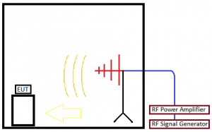

**Conducted Immunity**: During conducted immunity testing, an electromagnetic field is generated by an RF signal generator and amplifier. This electromagnetic field is coupled to a products signal, data or power port via an injection device (commonly a CDN, or ‘Coupling/Decoupling Network’ is used as an injection device). This kind of conducted immunity testing is continuous in nature and is called “Radio-frequency Continuous Conducted” in many standards. Typically conducted immunity testing is applicable to AC & DC ports and signal cables longer than 3m in length.

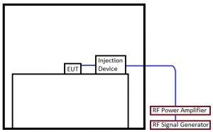

**Power-frequency Magnetic Field Immunity**: A fluctuating magnetic field is produced by a magnetic coil that oscillates at the mains power frequency (50/60Hz). The EUT is placed inside this fluctuating magnetic field and exposed for enough time to evaluate the performance of the product. Magnetic Field Immunity Testing is usually only required for [Magnetically Susceptible Devices](https://www.emcbayswater.com.au/blog/magnetic-field-immunity-testing-magnetically-susceptible-devices/).

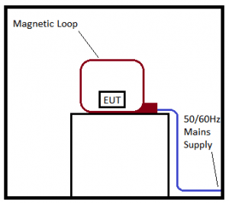

### **Transient Immunity Testing**

Transient phenomena are short bursts of energy that a product under test will be exposed to for a very short amount of time. Like continuous immunity, transient immunity is applied to a products enclosure port, signal/data ports and power ports where applicable.

**Electro-static Discharge (ESD)**: ESD pulses are applied directly to the enclosure of a device and indirectly to vertical/horizontal coupling planes in close proximity to the product under test at test levels specific to the standard being applied. For further information on the effects Electro-static Discharge and the possible ESD compliance solutions please check out the article: [Electrostatic Discharge common EMC solutions](https://www.emcbayswater.com.au/blog/electrostatic-discharge-common-emc-solutions/).

**Electrical Fast Transient (EFT) / Burst**: Fast transients are a series of short pulses that are high in amplitude and repetition frequency with a short rise time. Fast transient phenomena are most often caused by high speed switching events such as interruption of inductive loads and relay contact bounce etc. Typically fast transients testing is applicable to AC & DC ports and signal cables longer than 3m in length.

**Surges**: Surges are a type of transient phenomena produced by high powered switching events, magnetic/inductive coupling and even lightning. Surge testing on the mains port of a EUT is applied at several phase angles of the mains supply. Typically surge testing is applicable to AC ports and sometimes also DC ports and in some EMC product standards signal cables longer than 30m in length or if the cable may run outside of a building. For further information about the surge, fixes check out our article [Surges EMC testing typical problems and solutions.](https://www.emcbayswater.com.au/blog/surges-emc-testing-typical-problems-solutions/)

**Voltage Dips, Short Interruptions (VDI) and Voltage Variations**: The purpose of voltage dips and short interruption testing is to simulate faults in the power network. These faults may be caused by power-cuts (blackout/brownout events) or by sudden large changes of loads. Voltage variations are typically caused by continuously varying loads connected to the power network. A voltage dip or interruption is a two-dimensional phenomenon that is characterised by the residual voltage (mains voltage after the specified dip) and duration (how long the dip in nominal voltage is applied to the product). This test is only applicable to AC input ports of products.

**Pulsed Magnetic Field**: Like the power frequency magnetic field immunity testing, the product under test is placed inside a magnetic loop. Unlike power frequency magnetic field testing, rather than exposing the EUT to a continuously fluctuating magnetic field (oscillating at 50/60Hz) the EUT is exposed to a magnetic field pulse, provided by a transient generator. The magnetic pulse is high in amplitude but has a short rise time, after which the performance of the product is evaluated to ensure normal operation.

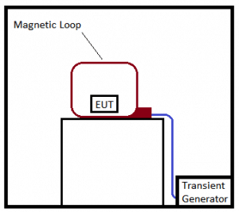

(https://www.emcbayswater.com.au/blog/emc-testing/commercial-emc-testing/guide-electromagnetic-compatibility-emc-testing-methods/)\

# **Why is EMC important?**

Top of Form

When designing electronic products, electromagnetic compatibility is a concern for all engineers, and product regulations often require conformity to strict EMC rules. What is EMC, why is it important, and how can it be reduced?

## **What is EMC?**

The term EMC stands for electromagnetic compatibility, [and it is concerned with ensuring that different electrical systems can operate in the same environment](https://en.wikipedia.org/wiki/Electromagnetic_compatibility#:~:text=Electromagnetic%20compatibility%20(EMC)%20is%20the,as%20electromagnetic%20interference%20(EMI)%20or) without interfering with each other.   Generally speaking, EMC can be seen to have been achieved when a circuit emits EM radiation under specified limits (usually by law) and remains unaffected when exposed to specified amounts of EM radiation.

## **Why is EMC important?**

The main goal of EMC is to ensure that electronic circuits operate correctly when exposed to external EM radiation, and to ensure that the electronic circuit in question does not emit “stray” EM radiation. To better understand why this is important. Let’s take a look at a very famous example of where EMC was not considered; mobile signals. If a phone is placed sufficiently close to a speaker you can sometimes hear the famous “Bip Bip Bip”. The reason this happens is that signals sent by the mobile to the cell tower, despite being well above audio levels, modulates signals at audio frequencies, and the speaker can detect and amplify these signals. In this example, the speaker is susceptible to the stray EM radiation from the mobile, and the mobile has generated EM radiation that can affect the performance of other circuits.

Thus, EMC is important in circuit design to make sure that external signals cannot upset the normal operation of circuits, and the operation of that circuit does not affect other circuits. This need to reduce interference is the reason why most markets around the world have regulations on how much radiation a circuit can emit, and how much interference it needs to be able to handle. Therefore, EMC is also important to consider as products cannot be sold if proper EMC controls are not implemented.

## **How can EMC radiation be reduced?**

[Improving EMC in a circuit is no small feat](https://www.analog.com/en/technical-articles/passing-the-radiated-emissions-test-how-to-eliminate-complex-emi-mitigation.html), and the nature of EM radiation must be fully understood before trying to reduce it. Generally, there are two methods in which EM radiation can interfere with a device; radiated and conducted. Radiated emissions are those caused by electromagnetic waves (i.e. radio), while conducted are those caused by electrical signals coupling from interfering sources (such as mains hum into a speaker). Methods for protecting against outside interference are also just as effective for protecting outside devices from generated EM interference.

While immunity to EMC is important, [it is often best to start with emissions as this is generally the primary cause for devices failing](https://www.silabs.com/documents/public/application-notes/an1131-layout-guide.pdf) during the product testing stage. Once emissions are identified, they can be removed by either changing the design to emit less or incorporate methods for absorbing emissions before they get to the outside world.

## **Reducing Emitted Emissions at the Source**

Most emissions from modern electronics come in the form of radio waves, and these are almost always caused by high-speed switching circuitry. Common culprits include switch-mode power supplies (SMPS), motor controllers, radio circuits, high-speed buses, and I/O connectors.

The reason why high-speed circuitry often causes issues is the use of high-frequency square waves with large slew rates (i.e. the sudden change from a 0 to a 1). Square waves can be mathematically modelled as an infinite number of sine waves at odd harmonics combined, and this is exactly what is produced in the EM world. When a signal switches from a 1 to a 0, many radio emissions at odd harmonic frequencies are produced, and these can cause interference in other devices that pick them up. Therefore, such emissions can be reduced by decreasing slew-rate (i.e. making square waves more trapezoid in shape).

In many cases, emissions can come from switching noise (such as those found in SMPS). In these cases, additional components can be added to a circuit to bypass these signals and prevent them from injecting noise into other areas as well as causing emissions. For example, decoupling capacitors placed around integrated circuits not only help to prevent switching noise from interfering with the normal operation but can prevent emissions from the power lines. Resistors, capacitors, and inductors can also be used as filter components for I/O, and prevent both emissions leaking from I/O connectors as well as preventing emissions from escaping at I/O cables.

Another method for preventing emissions comes from ensuring that the length of PCB traces are not a multiple of the wavelength of the signal frequency in that trace. Alternating current in a wire produces radio waves whose frequency match the frequency of the AC; this is what an antenna does. But for an antenna to reach peak efficiency, it must be designed so that the length of the antenna is a multiple of the wavelength of the desired frequency. Since an antenna is nothing more than a length of wire, a PCB trace can very easily become an antenna. It’s best to see an example to understand how this works.

A PCB trace is to carry a 2GHz signal. This 2GHz signal can produce a 2GHz radio signal which has an approximate wavelength of 15cm. Therefore, the length of the PCB trace should be less than 15cm, and not be a length that is a multiple (i.e. 7.5cm, 1.5cm, etc.).

## **Absorbing Emitted Emissions**

Sometimes emissions cannot be entirely removed, [and so in these situations, it is far easier](https://www.eit.edu.au/cms/resources/books/practical-shielding-emc-emi-noise-reduction-earthing-and-circuit-board-layout)to absorb them before they get to the outside world. This is mostly done using Faraday cages that either surround noisy components or an entire product, and the shield is often connected to a ground (i.e. 0V on the internal circuit).

Metal shielding is commonly found on Wi-Fi and Bluetooth SoCs that are directly soldered to PCBs. The metal shield surrounds the main IC as well as its supporting components and is often soldered to ground. The antenna is a PCB trace that goes beyond the metal case to an area of the board that has its ground planes removed.

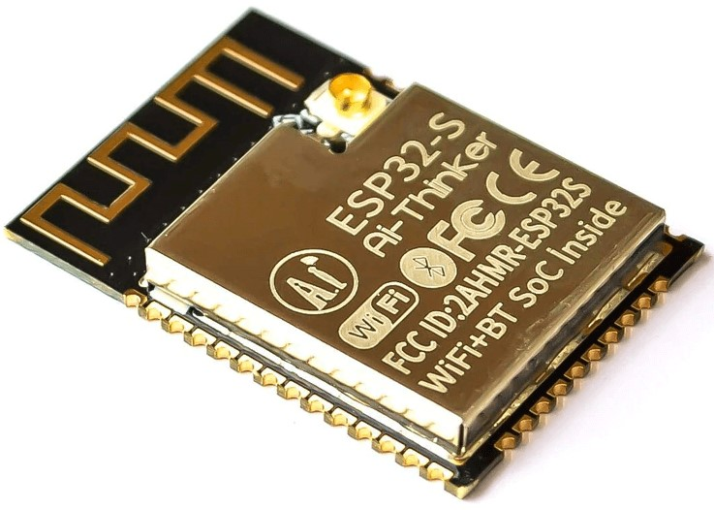

Absorption of emissions can also be done using power planes on a PCB. For boards that have more than two layers, the two innermost layers are often used as power planes (one layer ground, the other power), and these can be effective at absorbing stray emissions. The most outer layers are often reserved for signals, and even these layers will include ground pours. From there, stitching via can be used to surround circuitry that is exceptionally noisy (such as power handling areas), and these stitching via help to create Faraday cages.

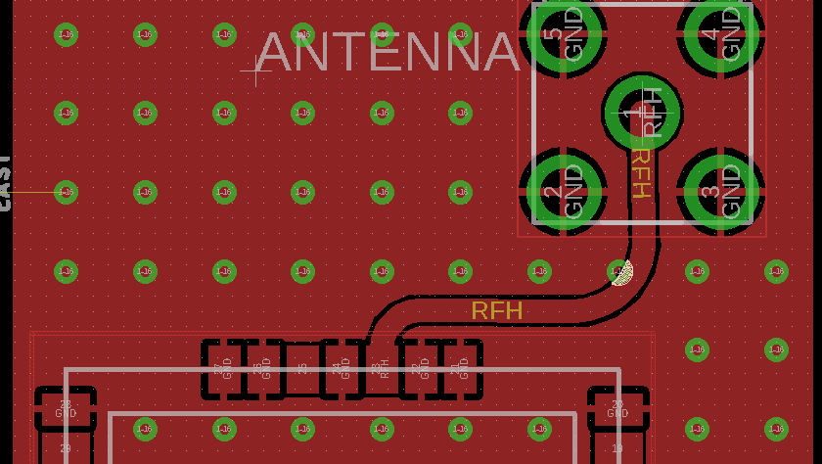

## **Conclusion**

EMC is not an easy feat to accomplish, and this article merely provides a brief introduction as to the causes of emissions, and how to fight back against them. Engineers need to consider EMC at all stages of circuit design, and the earlier EMC is considered in a project, the easier it is to develop. Projects that don’t consider EMC until the end can often result in a complete redesign costing both time and money.

(https://www.electropages.com/blog/2020/09/why-emc-important)

What is Electromagnetic Compatibility (EMC) Testing?

EMC/EMI testing is a critical step in the design and manufacturing processes of electronic devices. Various regulatory bodies, including the [FDA](https://www.fda.gov/radiation-emitting-products/radiation-safety/electromagnetic-compatibility-emc), [FCC](https://www.fcc.gov/general/equipment-authorization-measurement-procedures), and [ISO](https://www.iso.org/ics/33.100/x/), have set specific limits on the emissions that can be released from an electronic device. These EMC (electromagnetic compatibility) regulations provide improved reliability and safety for anyone using electrical and electronic equipment because they assure the device does not interfere with the operation of other equipment or fail to operate as intended due to interference from others emissions. Failing to pass EMC compliance testing can result in fines and product recalls.

So purchasing instruments that can spot potential EMC/EMI issues prior to EMC testing is worth the investment.

Though EMI and EMC are very similar, there are a few differences between the two.

## **What is EMI?**

Sometimes called radio frequency interference (RFI), electromagnetic interference (EMI) occurs when electromagnetic energy disrupts the operation of an electronic device. The source of EMI can be man-made, such as other electrical devices like switch-mode power supplies, personal computers, or naturally occurring, such as electrical storms, solar radiation, or even cosmic noises.

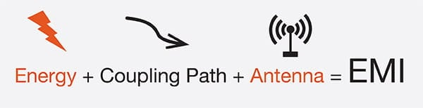

## **What is EMC?**

Electromagnetic compatibility (EMC) is the ability of a device to operate as intended in an environment with other electrical devices or sources of EMI without affecting those other devices. A device is said to be EMC-compliant when it does not influence the electromagnetic environment to the extent that other devices and systems are negatively affected.

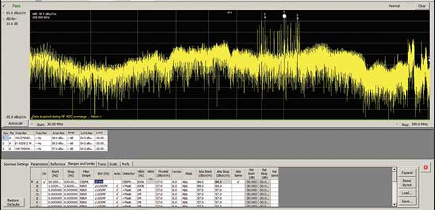

## **What is EMI and EMC testing?**

To ensure compliance with EMI and EMC national and international regulations, many companies employ the services of a specialized testing facility. Since these tests are expensive—even if the product fails—several companies perform EMC pre-compliance testing in-house. If they have a sophisticated enough lab, companies may also perform EMC compliance testing in-house.

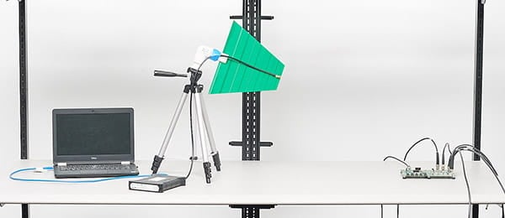

EMC/EMI testing is typically divided into two categories: immunity testing and emissions testing.

## **Types of EMC tests**

When electronics are submitted to EMC testing labs, there are many types of EMC tests these labs run. Generally speaking, EMC testing is divided into two categories: immunity testing and emissions testing.

### **Immunity testing**

Immunity testing is the process of transmitting RF energy onto a device under test (DUT) (also referred to as equipment under test or EUT) to determine if the DUT/EUT operates correctly when in such an environment.

### **Emissions testing**

Emissions testing is the process of measuring the RF emissions – both radiated and conducted – of a DUT/EUT to determine if its emissions levels do not exceed the limits defined by the appropriate standard. Emissions testing includes both radiated and conducted emissions tests.

#### Radiated emissions

[Radiated emissions](https://www.tek.com/blog/pre-compliance-emc-test-equipment-guide-radiated-emissions) are the intentional and unintentional release of electromagnetic energy from an electronic device. A radiated test is performed to ensure emissions emanating from the DUT or EUT comply with the applicable limits.

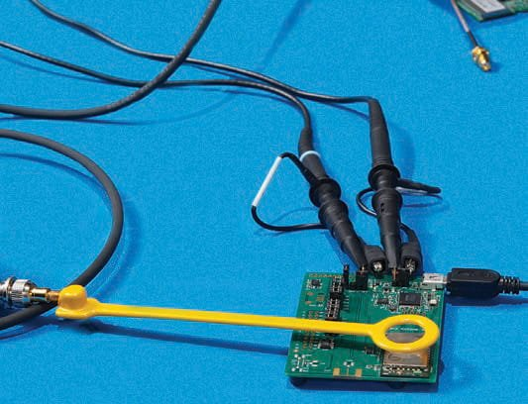

#### Conducted emissions

Conducted emissions are the coupling of electromagnetic energy from a device to its power cord. Like radiated emissions, the allowable conducted emissions from electronic devices are controlled by different regulatory agencies and testing is performed to ensure emission levels are below the applicable limits.

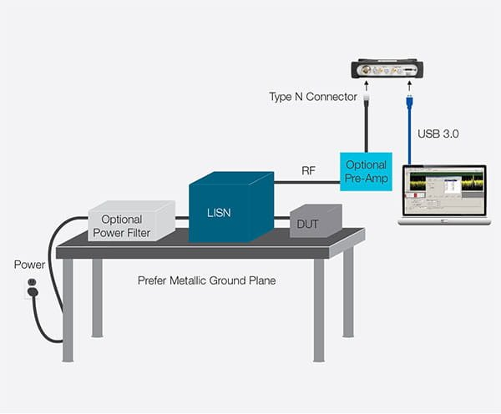

## **EMI/EMC testing applications and standards**

EMI/EMC testing is part of the product development process and testing is mandatory in most markets. Though all electronic devices are subject to EMC testing, the following are some of the most common applications for EMC testing and standards that devices and equipment need to meet.

| **MARKET SEGMENTS** | **Equipment Type** | **STANDARDS** | | | | |
| --- | --- | --- | --- | --- | --- | --- |
| **IEC/CISPR** | **CENELEC/EN** | **FCC** | **MIL-STD** | **DEF-STAN** |
| ISM MEDICAL | Industrial, scientific and medical equipment | CISPR 11 | EN 55011 | CFR Title 47 Part 18 |  |  |
| Medical electrical apparatus | EN 60601-1-2 |
| AUTOMOTIVE | Vehicles, boats and internal combustion engines | CISPR 12 | EN 55012 | CFR Title 47 Part 15(*) |  |  |
| Components and modules on board vehicles | CISPR 25 | EN 55025 |  |  |  |
| MULTIMEDIA | Sound and TV broadcast receivers | CISPR 13 | EN 55013 | CFR Title 47 Part 15 |  |  |  |
| Information technology and telecommunications equipment (ITE) | CISPR 22 (superseded by EN55032) | EN 55022 (superseded by EN55032) |  |
| Professional audio/video/multimedia equipment | CISPR 32 (replaces CISPR 13 and 22) | EN 55032 |  |
| APPLIANCES | Electrical devices, household appliances and tools | CISPR 14-1 | EN 55014-1 | CFR Title 47 Part 15 |  |  |  |
| LUMINAIRES | Fluorescent lamps and luminaires | CISPR 15 | EN 55015 | CFR Title 47 Part 15 |  |  |  |
| MILITARY | Military equipment and systems |  |  |  | MIL-STD-461G | DEF-STAN 59-411 |  |

## **EMC testing labs**

EMC-compliance tests are commonly done off-site prior to the production of a device. Open-air test sites, or OATS, are the reference sites used for most standards. They are especially useful for emissions testing of large equipment systems. However, RF testing of a physical prototype is more often carried out indoors, in a specialized anechoic chamber. Types of chambers include anechoic, reverberation, and the gigahertz transverse electromagnetic cell (GTEM cell).

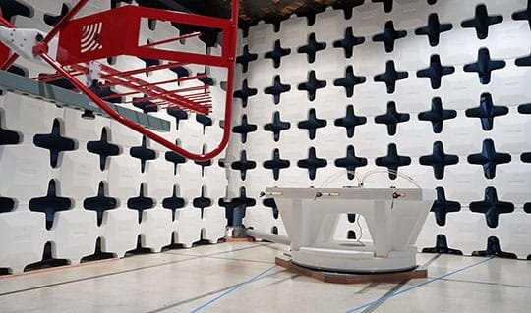

## **EMC testing procedure and average pass rate**

Roughly 50 percent of products pass their first EMC compliance test when pre-compliance isn’t considered, so it’s essential to understand the process and standards a device is tested to in order to increase your chances of success.

#### Know your standards

EMC compliance testing can take up to two weeks to complete—not including the time it takes to get your product into the test queue—and can cost up to $20,000 per submission. A failure in EMC compliance can result in expensive redesigns and product launch delays. And since nearly 50 percent of products fail their first EMC compliance test when pre-compliance isn’t considered, it’s likely that you’ll need to repeat your visit to the test house, multiplying costs over time.

#### Conduct pre-compliance EMC testing

EMC compliance testing can take up to two weeks to complete—not including the time it takes to get your product into the test queue—and can cost up to $20,000 per submission. A failure in EMC compliance can result in expensive redesigns and product launch delays. And since nearly 50 percent of products fail their first EMC compliance test when pre-compliance isn’t considered, it’s likely that you’ll need to repeat your visit to the test house, multiplying costs over time.

#### Find an EMC testing lab

Once a product has gone through pre-compliance testing and passed the test with a sufficient margin, it needs to be formally certified by an EMC testing lab. Accredited labs are the gold-standard for EMC testing and choosing an accredited lab is always recommended—though not necessary—to ensure your device is ready to go to market. There are, however, some instances that require certification from an [FCC-accredited lab](https://apps.fcc.gov/oetcf/eas/reports/TestFirmSearch.cfm), including devices that fall under the 'certification' authorization procedures.

## **How to pass EMC compatibility testing**

EMC pre-compliance testing is a fast and affordable way to ensure products pass EMC tests the first time In the early development stages, design-for-EMC techniques are combined with diagnostics to build products with low susceptibility to both external and internal interference. Later in the development cycle, pre-compliance testing is used to catch compliance problems and improve the probability of a successful first pass of full EMC-compliance testing.

Additional benefits of pre-compliance EMC testing, include:

1. Detects errors early, fixing potential issues
2. Lowers testing and design costs
3. Projects become more agile
4. Lowers risk of failure and leads to assured compliance
5. Addresses both over and under design and engineering

For a better understanding of how a Tektronix pre-compliance testing setup compares to an EMC testing lab, watch this short video.

Play Video

### **Setting up a pre-compliance EMC test lab**

When selecting a test site, rural areas, conference rooms, and basements are good options because they minimize external signals that might mask the DUT emission levels you are trying to measure. Other considerations for improving accuracy include having a good ground plane and reducing the number of reflective objects around the test area.

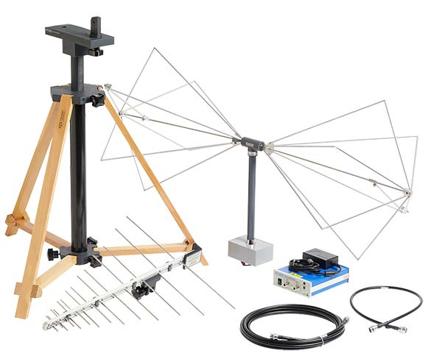

### **EMI and EMC testing products**

The goal of EMC pre-compliance testing is to mimic the compliance test set up within an acceptable margin to uncover potential problems and reduce risk of failure prior to the expensive compliance test. [EMC pre-compliance testing](https://www.tek.com/product-features/new---emcvu-your-emi-emc-pre-compliance-software) typically involves:

* [Spectrum analyzer](https://www.tek.com/spectrum-analyzer) with quasi-peak detector
* Preamplifier (optional)
* Antenna with non-metallic stand for radiated emissions
* Line impedance stabilization network (LISN) for conducted test
* Power limiter for conducted test
* EMC near-field probes for diagnostics (optional)
* [Oscilloscope](https://www.tek.com/oscilloscope) with frequency and time correlation capabilities to assist in debugging (optional)
* [EMC testing software](https://www.tek.com/landing-page/emcvu-software-and-accessories)

## **EMC testing resource center**

##### APPLICATION

#### EMC/EMI pre-compliance test setup accessories

#### [EMC/EMI pre-compliance test solutions](https://www.tek.com/application/electromagnetic-interference-emi-and-electromagnetic-compatibility-emc)

Learn more about Tektronix EMC/EMI pre-compliance solutions and how to assemble a pre-compliance test setup, and get troubleshooting tips.

##### BLOG

#### Affordable EMC pre-compliance testing set up to minimize more expensive compliance test facilities.

#### [Financial benefits of EMI/EMC pre-compliance testing](https://www.tek.com/blog/financial-case-emi-emc-pre-compliance-test-solution)

Get an estimate of EMC testing costs and the saving you can realize when you set up an in-house pre-compliance testing solution.

##### CASE STUDY

#### Eggtronic case study using a Tektronix real-time spectrum analyzer to ensure their products adhere to EMC/EMI test standards

#### [Fast 3D EMC/EMI scan with Detectus scanning system and Tektronix real-time spectrum analyzers](https://www.tek.com/document/case-study/fast-3d-emc-emi-scan-detectus-scanning-system-and-tektronix-real-time-spectrum)

Download this customer case study to learn how the fast-growing start-up Eggtronic used a Tektronix real-time spectrum analyzer to enable an extremely fast scan procedure to ensure their products adhere to EMC/EMI standards.

##### APPLICATION NOTE

#### Troubleshooting EMC/EMI test issues with Tektronix EMCVu

#### [Troubleshooting EMC/EMI issues with Tektronix EMCVu](https://www.tek.com/document/application-note/emi-pre-compliance-testing-and-troubleshooting-tektronix-emcvu)

Download this application note to learn how to address common design failures early when the costs of a re-design are minimal.

(https://www.tek.com/what-is-emc-emi-testing)